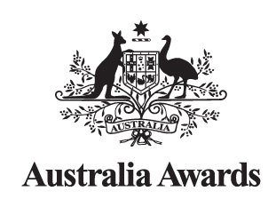

Approval for Lao Government employees to apply for Australia Awards
(This form is for GoL employees only)

The Chairperson
Australia Awards Laos

I approve the following employee as an applicant for the Australia Awards Scholarships commencing in 2023.

This is to certify that …………………………………………………………….…………………………………………… has been employed
(name of applicant)

by the Ministry of ......................................................................................................…………….……... since the year ...........................

and has worked in his/her current position at: ……………………………………………………..………..……………………………………...
(name of Division or Department)

for the period of ………………………………….... commencing ……………….…………………….
(number of years) (dd/mm/yyyy)

After returning from Australia the applicant is expected to be employed in the position of ……………..……………….…………….………

……………………….………………..….……… by.......................................................................................................................................
(name of Division, Department, Ministry)

OFFICIAL STAMP
The Authority’s Signature: ………………………………………………………………….
(signature)

The Signatory’s Name: ………………..…………………………………………………….
(please print name)

Position: Head of Personnel Department / Director General of Department
(Please circle the relevant position)

Organization: …………….…………………………………………………………………...
(please print)

The Authority’s contact details:
Tel: …………………………………. Email: ………………………………………...........

Date: ………………………………
(dd/mm/yyyy)

Note: If the applicant is unable to obtain the signature of an authorised person from his/her organisation, the applicant should contact the Scholarships Team to discuss this as early as possible during the application preparation.

